1. Create on Bash script to check if a directory is available or not  
   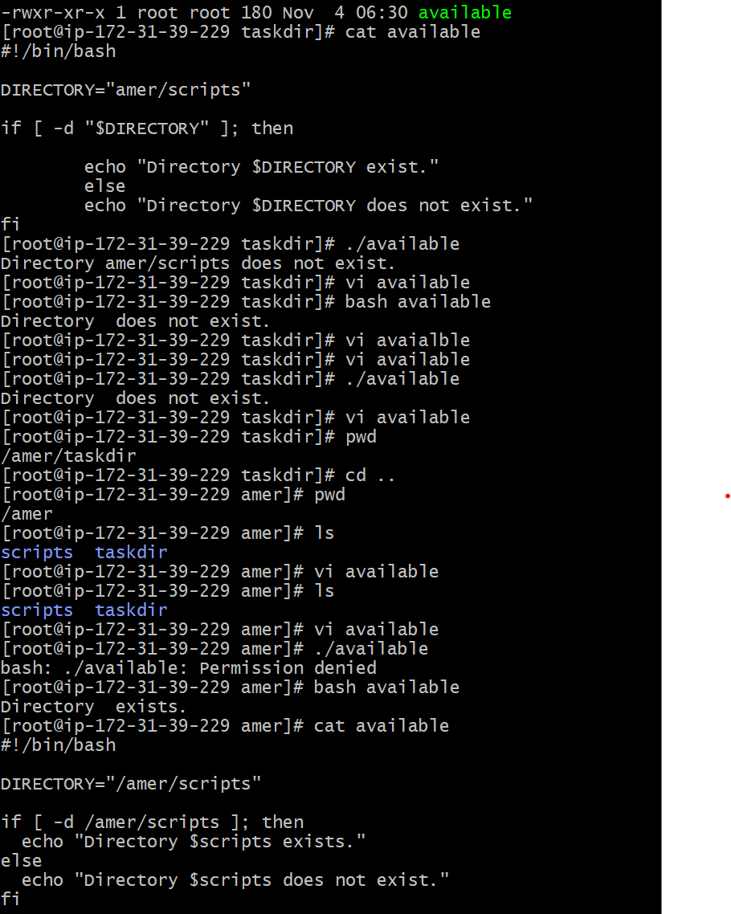
2. Create a bash script which will create multiple files  
     
   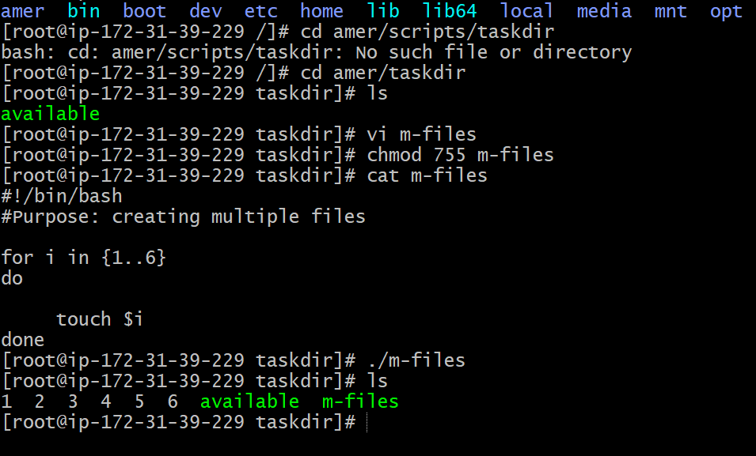  
     
     
   3) Create a bash script to take backup of a directory

4)Create a bash script to install nginx in ec2 server  
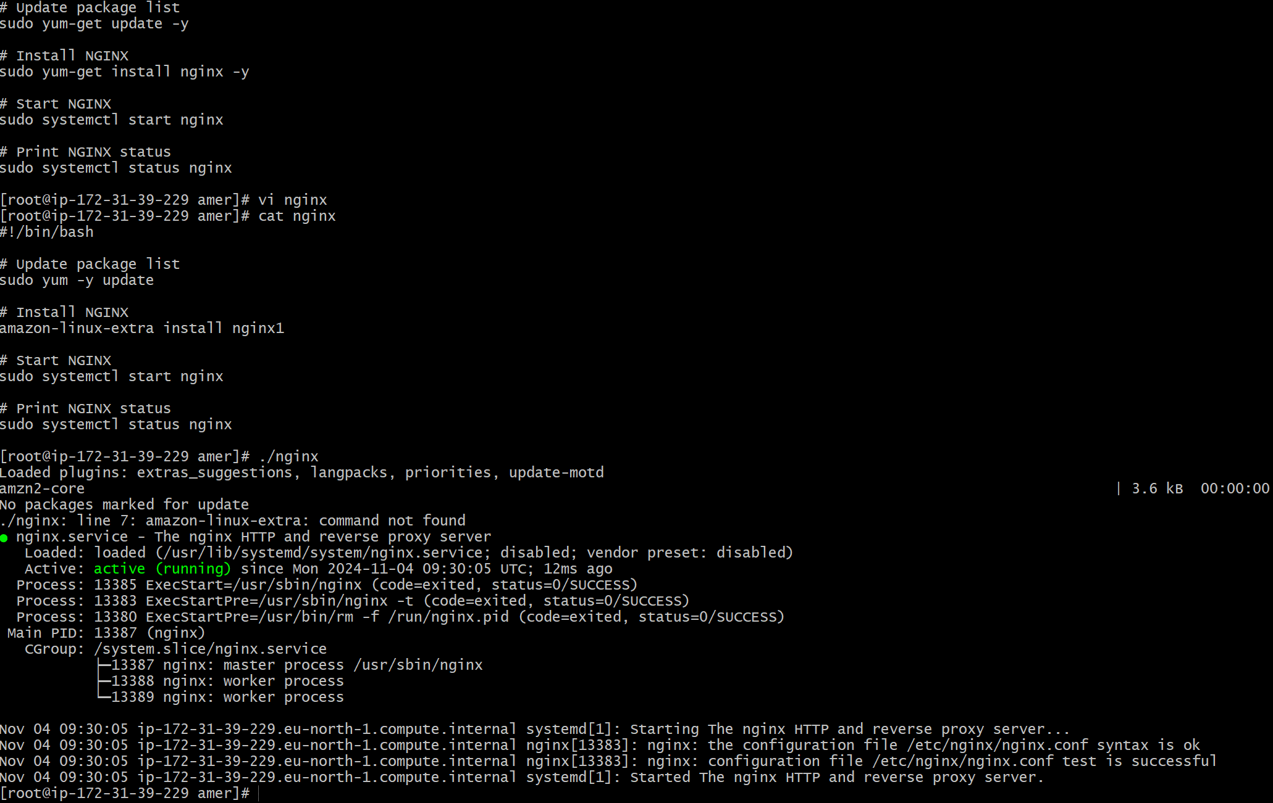  
  
  
5) Create a bash script to install Apache-tomcat in ec2 server  
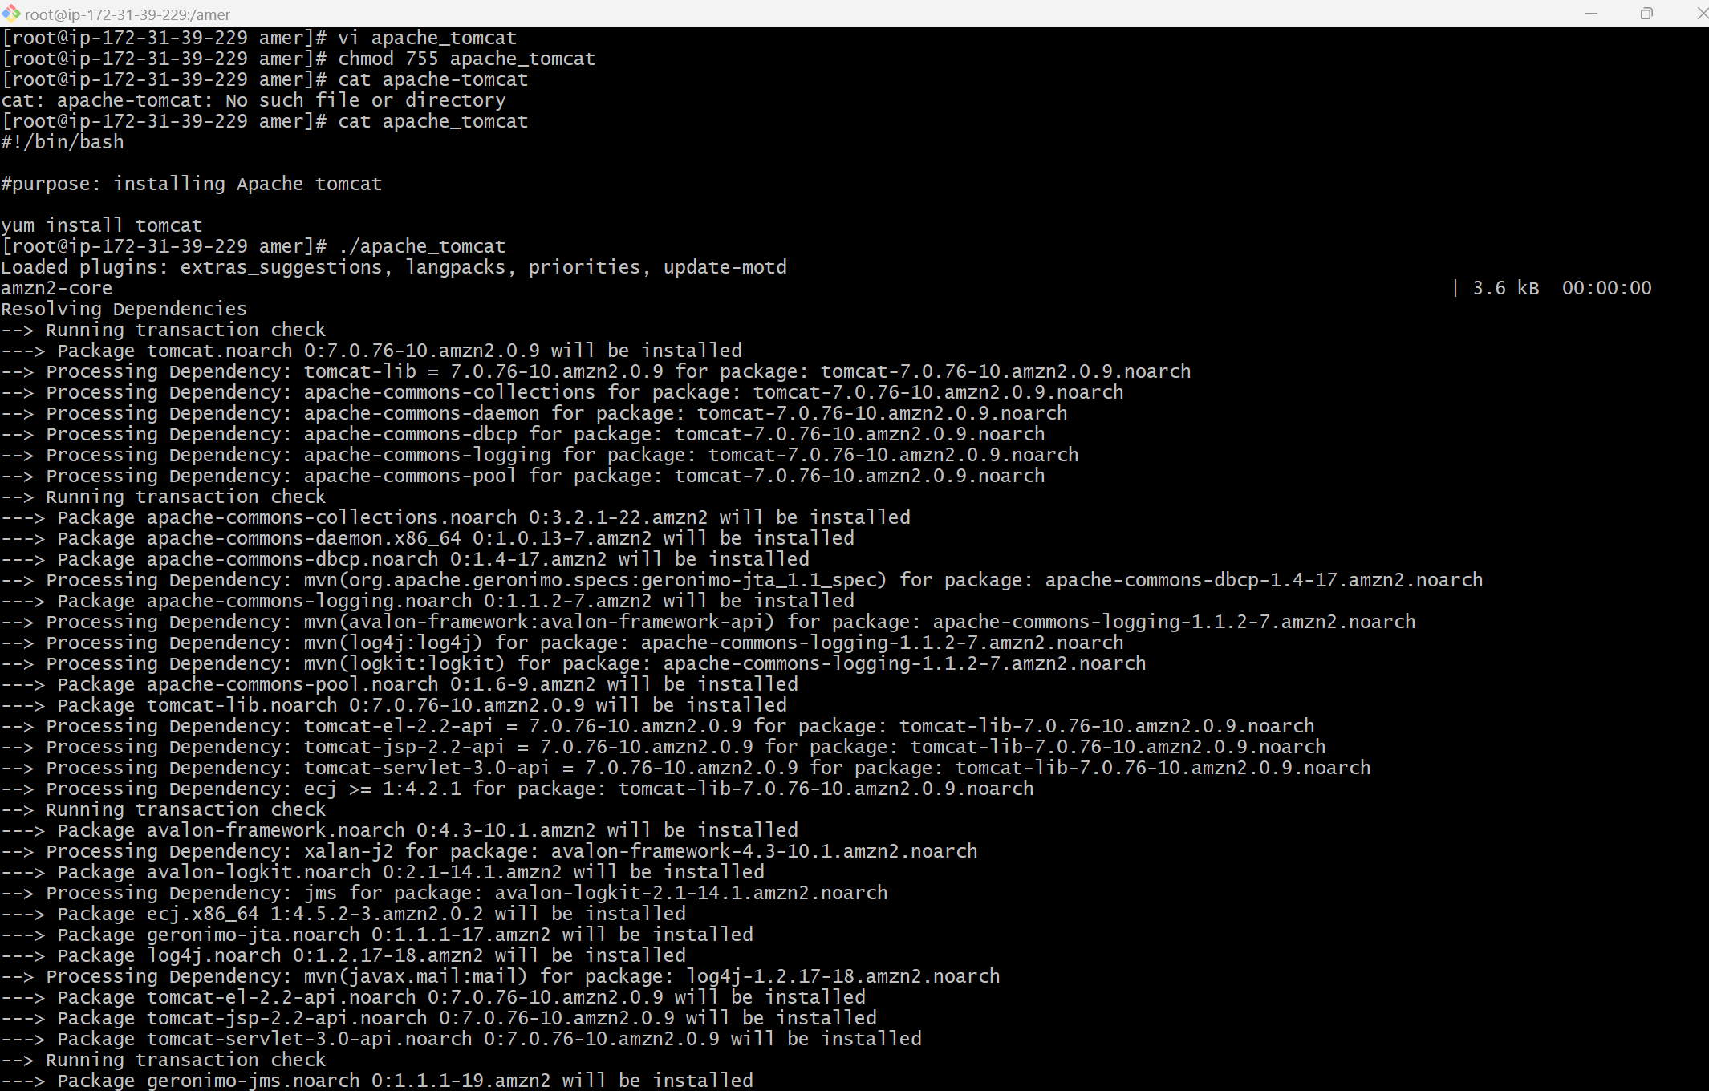

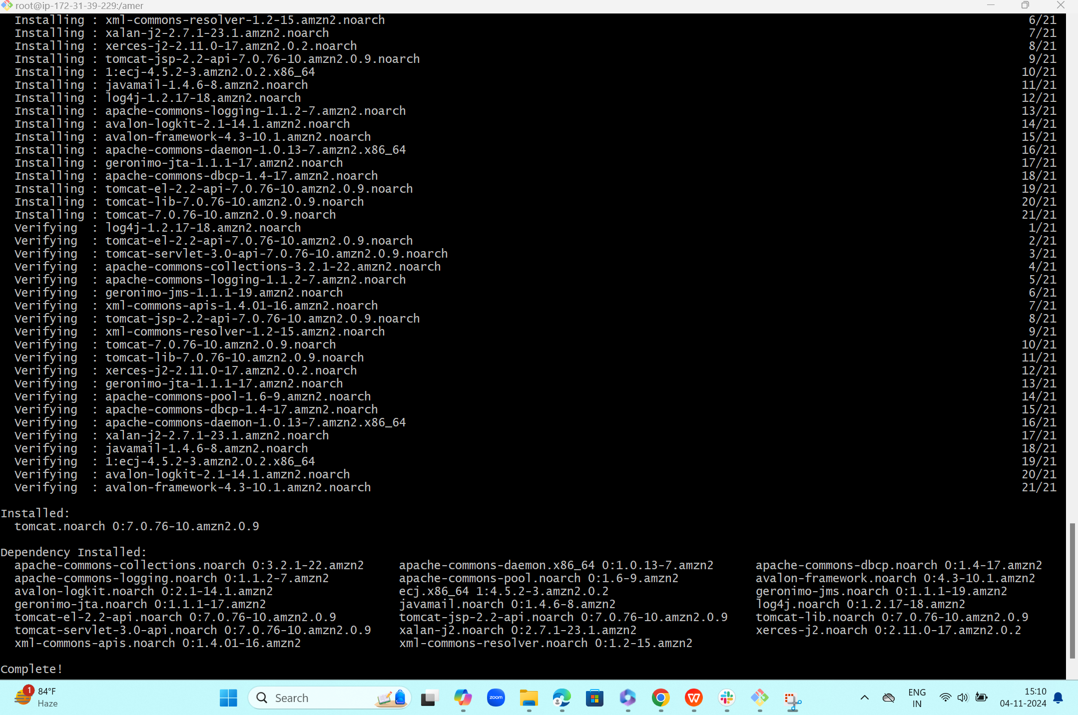

1. Create a bash script to check list if nginx service is running or not,if not running then script should start the service.

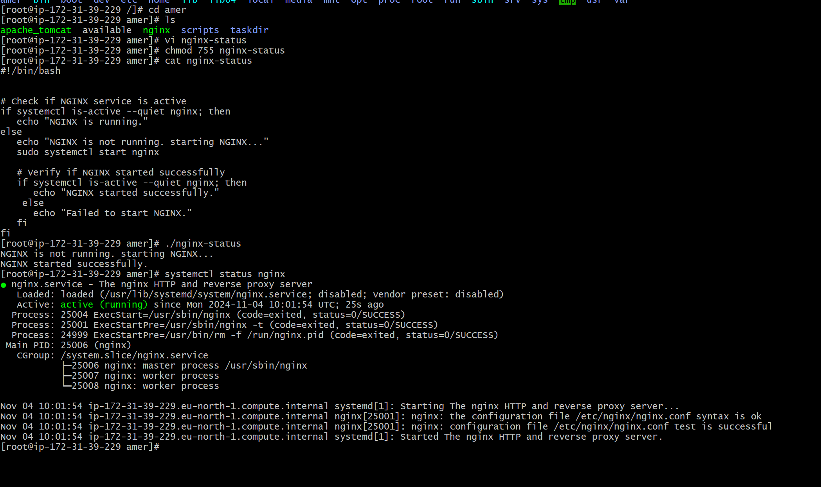  
  
  
  
  
  
  
7) Create a bash script for calculator  
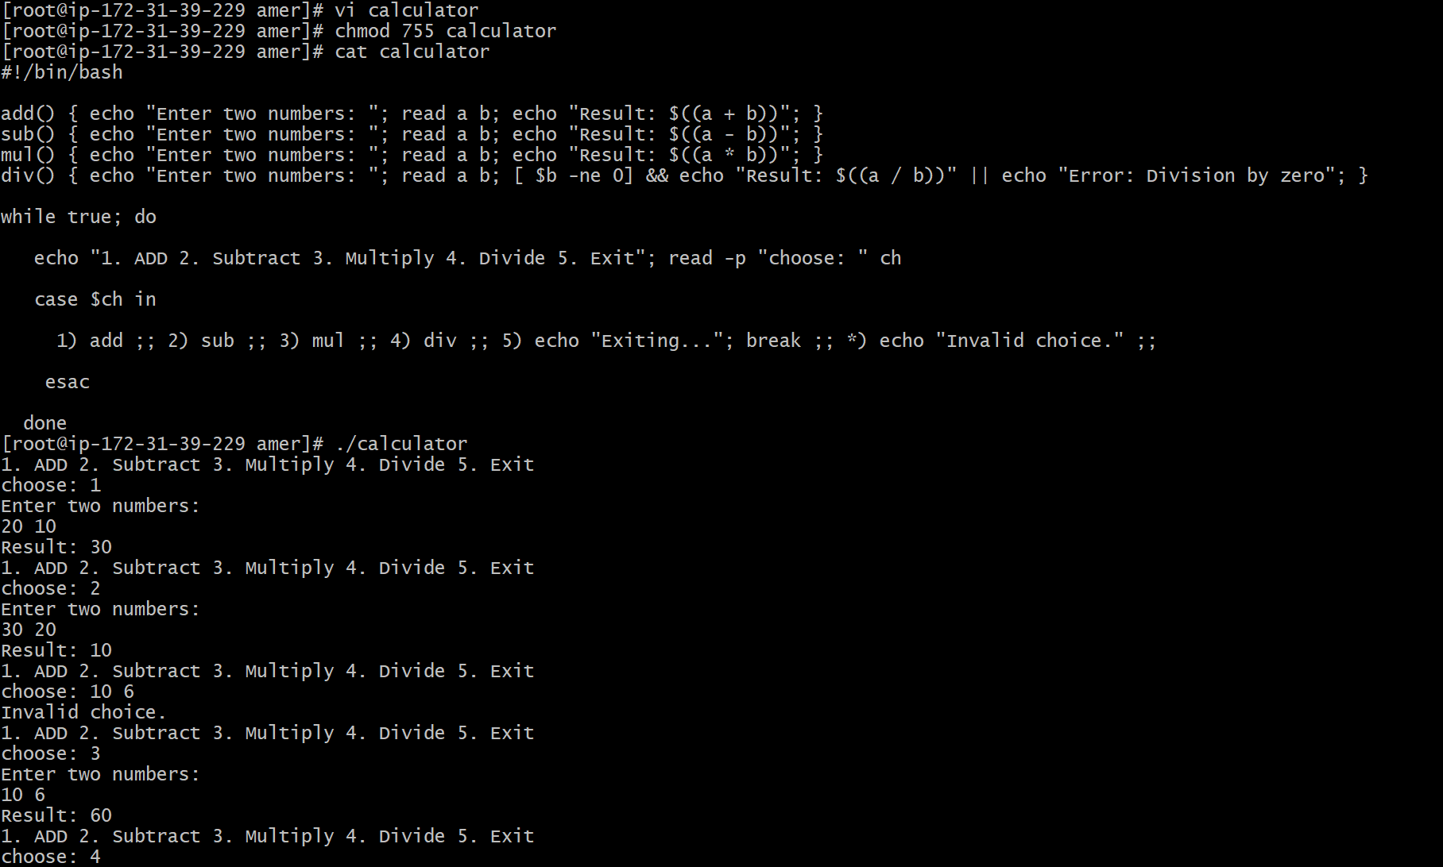

8) Create a bash script to check if directory is available or not,if not then create a directory

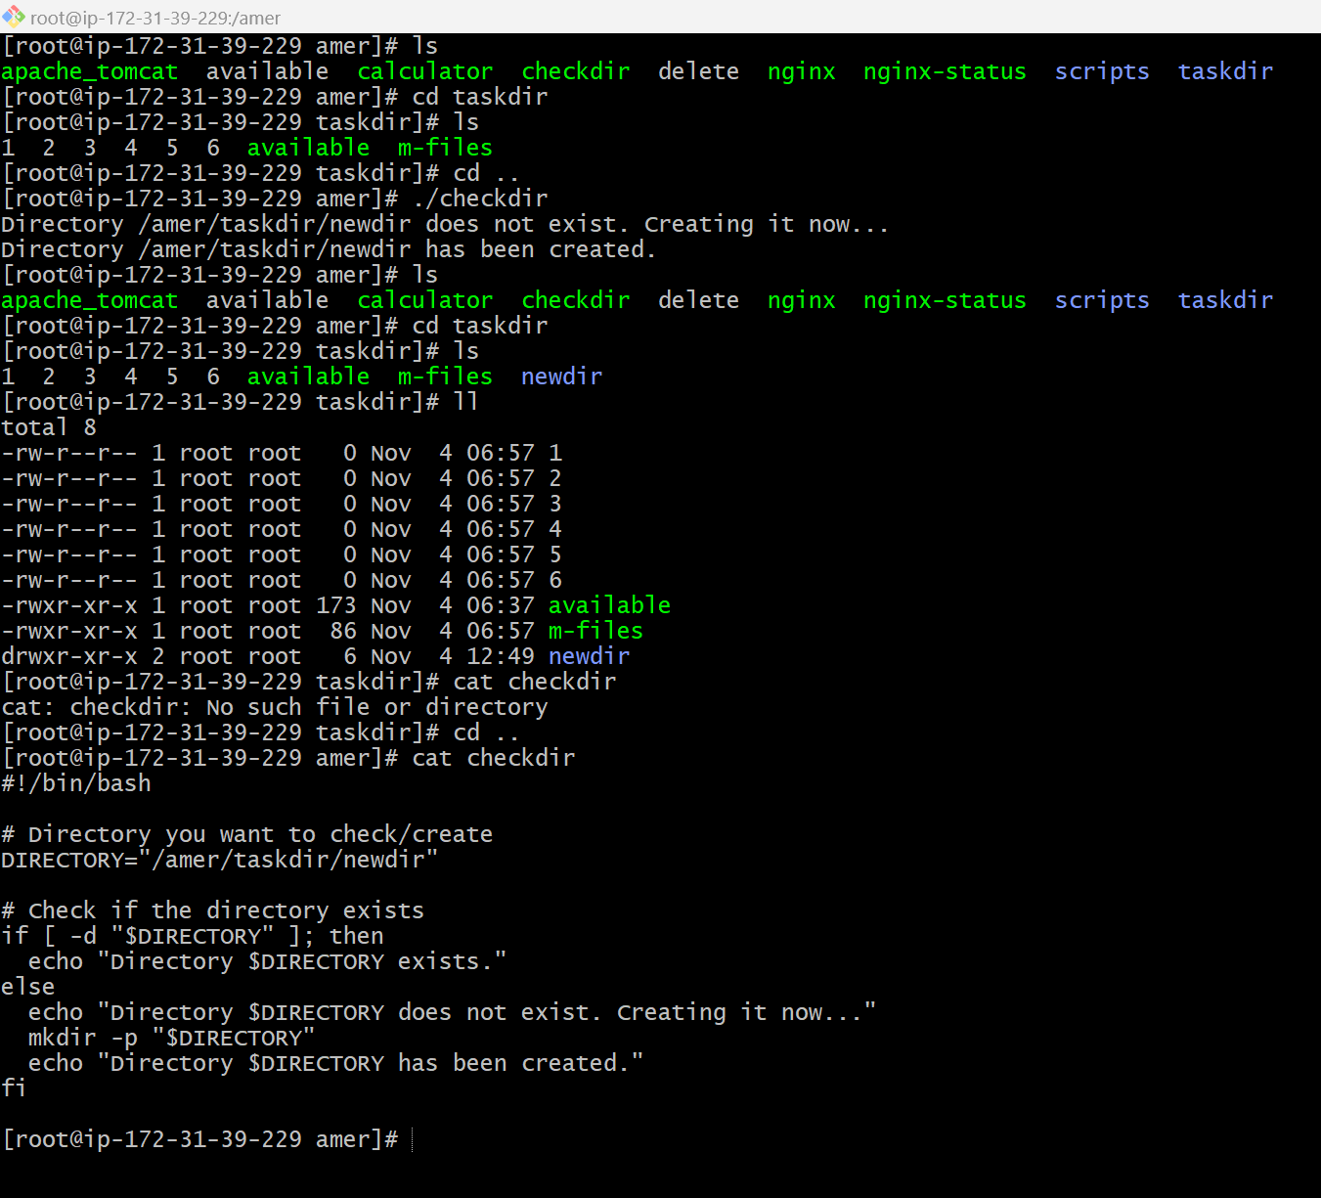

1. Create bash script to delete last 3 lines for a file  
   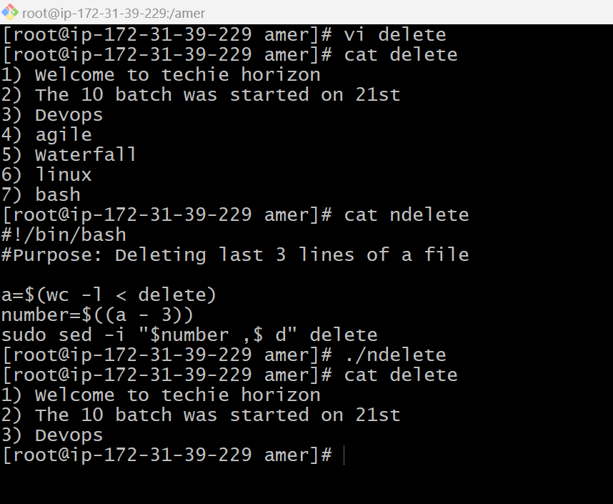

Exercise Crontab Entries :   
1) April 5th Midnight  
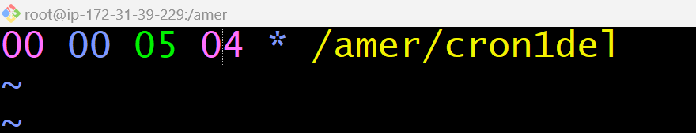

1. 5 th of Every November,Jan,June if it is a Thursday  
     
   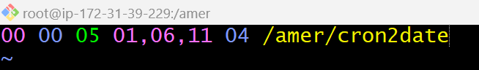  
     
     
     
   3) At 05 and 27th minutes of 9,10,11 hours everyday  
     
   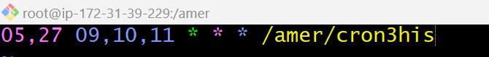  
     
     
   4) 34 min. of 9th hour on 15th Aug  
     
   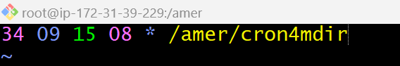  
     
     
   5) Every midnight  
   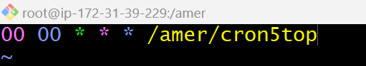

6) Every Weekend ( Saturday night 11.59 )  
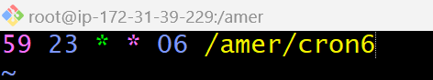  
  
  
7) After every reboot  
  
